==Passenger Cars A Displacement 1500 cc or less(excluding 1BOX and Minivan)
COROLLA X  Sold from October 2001  Toyota Motor Corporation  Model: TA-NZE121-AEPNK  Displacement: 1,496cc – Vehicle weight: 1,040kg  Length, width, height: 4,365 X 1,695 X 1,470mm  4door sedan, A/T, FF, Seating Capacity: 5  Tires: 175/70R14 84S BS B391 | 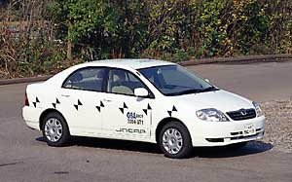

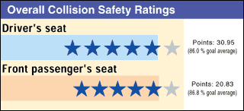 | Test Vehicle Weight | Safety Devices Installed on Test Vehicle
 | Full-wrap: 1,252  Offset: 1,248  Side: 1,125 | • Driver's air bag: Provided  • Front passenger's air bag: Provided  • Side air bag: Not Provided  • Seatbelt pretensioner: Provided  • Seatbelt Force (lord) Limiter: Provided
Click here for displaying results.

• Full-wrap Frontal Collision Test
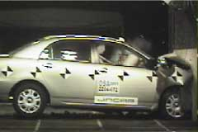
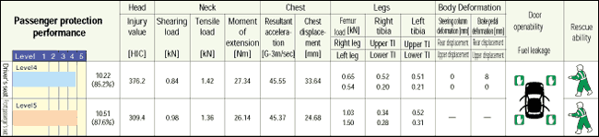
Click here for displaying results.
• Offset Frontal Collision Test
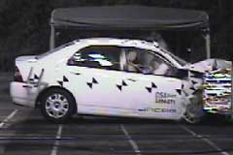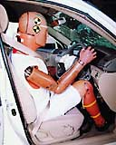
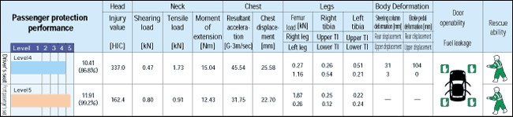
Click here for displaying results.
• Side Collision Test
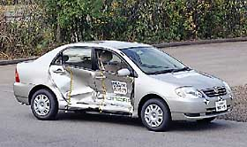
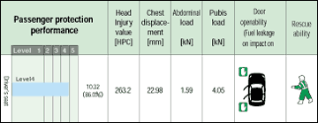
Click here for displaying results.

* | In the data for full-wrap and offset frontal collisions, the 'shearing load' and 'tensile load' columns show the maximum values (same in test data for all models).

